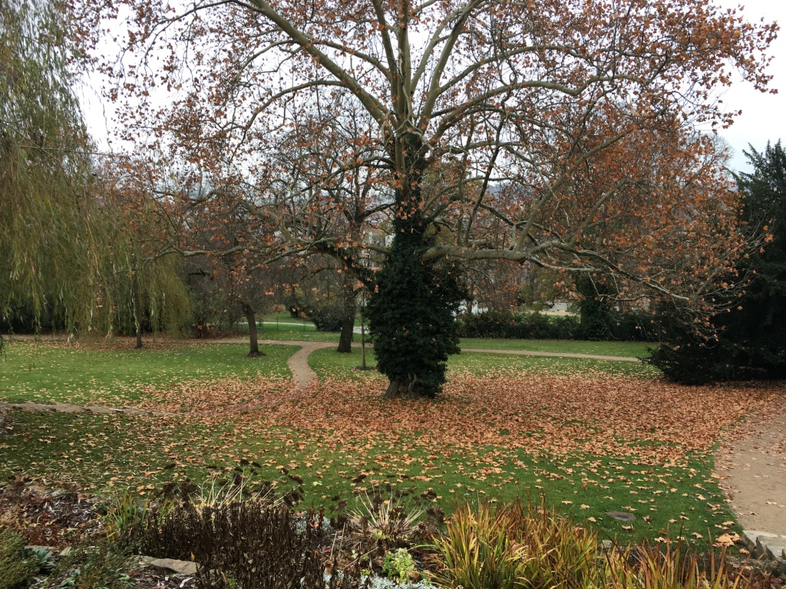
The garden at the Villa Tugendhat, Brno

This Blog of our winter journey in Central Europe is being written unacceptable late! My only excuse is having too much to do - but the reality is I thought I had already done it. Therefore it will be briefer than I would like, and it may well suffer from lapses of memory.

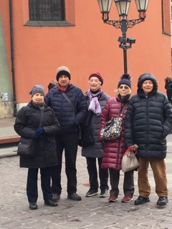
None of this detracts from the pleasure our fairly small group experienced from a winter journey so close to Christmas in these lovely cities. Both Krakow and Brno are modest sized cities, but their wintry aspect with everyone in colourful winter gear and their centres suffused with Christmas lights and decorations, made for magical settings for Australians used to sun, heat and the sea.

Krakow
Our first concert in Krakow was to be a Chopin recital by the 18 year old virtuoso Maria Moliszewska, but sadly she was replaced by a 40 something male pianist who both in his demeanour and his playing gave the impression he would much rather be somewhere else as far away as possible. The recital was in a nondescript room

It was cold in Krakow!

on the second floor of a city building, so it was quickly apparent this was not likely to be music-making of the front rank. Not a brilliant start to the musical experience of our tour.

Nevertheless we rugged up and enjoyed the exotic castles, churches, lanes and squares of the city with its flurries of snow. We collected on Friday 23rd at the brand new Opera House, all a brilliant dark red and glass both inside and out. The production of Donizetti’s Anna Bolena was good without having the last degree of excellence. The set’s constantly changing perspectives masked economy of means and the singing was first class, especially from the Anna and Enrico (Henry VIII). All the cast were Polish.

Brno
The central emphasis of the tour was the Centenary Janacek Festival in the composer’s birthplace Brno. We were there for a week staying in the comfortable Hotel Grandezza where most of us had spacious first floor rooms looking directly out on one of Brno’s main squares, which has crammed with the festive Christmas market, food stalls, and full of people from mid-morning until late at night. It was a pleasure just to stand at the window and take it all in.

Our first Brno concert was on Saturday 24 November
at 3 pm at the Löw-Beer Villa, a large elegant modern
house with a beautiful garden that led up a hill to the
famous Villa Tugendhat. We heard the Skampa Quartet,
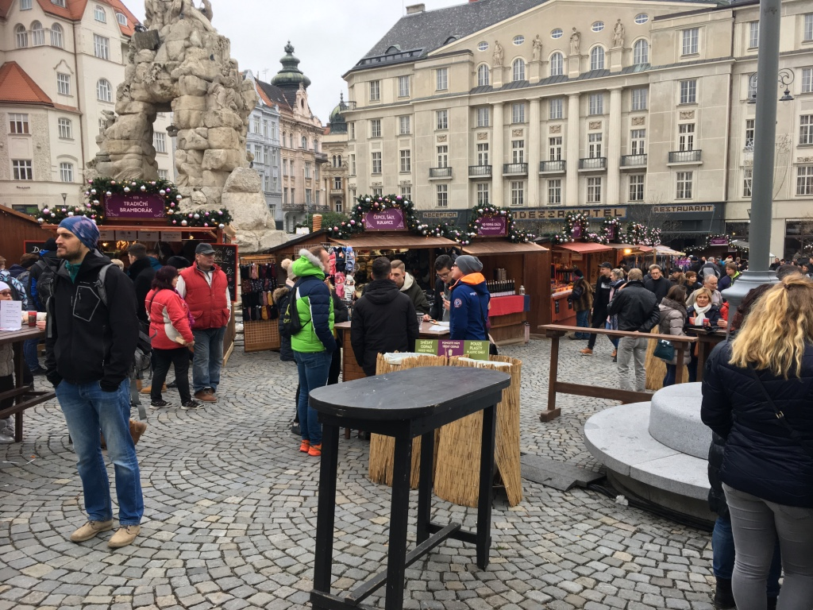
a leading Czech string quartet playing a challenging
program of Schönberg’s second string quartet, Bartok’s
3rd and Janacek’s Kreutzer Sonata Quartet. Inspired by
the composer’s relationship with Kamila Stosslova, the
passionate performance of the Janacek hit home to
everyone in the audience and the applause was
rapturous. This was a very strong start to our The square outside our hotel in Brno
visit to Brno.

The same day in the evening we attended a performence of Janacek’s opera Destiny (Osud) at the intimate traditional opera house, the Mahen Theatre. This was a highly dramatic contemporary take on the 1904 opera, never publicly performed in Janacek’s lifetime. It is a complex drama about a man’s experiences and mistakes in love and the intensity of the music and the drama was well portrayed. This was a production of the Moravian Silesian Opera Company based in the north of the country. At the performance, Andrew Neill and I met Paul Mauffray, an American conductor living in Brno and an expert on Janacek. We were to meet him several times during the week and later he led our group on an exploration of some of Brno’s interesting places.
On Sunday 25th in the afternoon, we gathered at the beautiful Villa Tugendhat, designed in 1930 by Mies van der Rohe, at the top of the garden with the previous day’s Löw-Beer Villa nestling below. The program of piano music was played by top Czech pianist Martin Kasik who spoke briefly about each piece in a fascinating program of central European music by Korngold, Kodaly and Janacek. We sat in a large room with a complete glass wall opening on to the autumnal garden on one side, adding greatly to the contemplative nature of the recital.

That same night we went to the Janacek Theatre, a large modern lyric theatre with little pretension to elegance, but offering good acoustics and facilities for opera, for a production by Opera Vlanderen, a leading Flemish company, of Janacek’s The Makropoulos Affair. This was one of the main attractions of the Festival and we were offered a very contemporary version of the opera set in a modern house with a view of the garden outside. The ageless 300 year old heroine Elinor Makropoulos was portrayed as a world weary punk style drug addicted singer, a very effective treatment and very different from the powerful well dressed opera singer usually presented. This production had its premiere in 2016 and is the work of leading Hungarian film director Kornél Mundruczó, whose films have often gained awards at leading festivals such as Cannes and Sundance.

Vienna
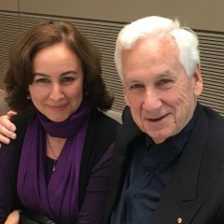
On Monday 26th, we had a complete change of pace and took a private coach on a two hour trip to Vienna. It snowed all the way much to everyone’s delight, but in Vienna it turned to cold rain. Nevertheless it was a full and fabulous day starting with a visit to what was possibly the most comprehensive exhibition of Pieter Bruegel the Elder’s paintings ever brought together anywhere at the Kunst Historisches Museum. The opportunity to see so many of his famous paintings up close and to study his incredible detail was wonderful, especially as some of the works exhibited were different versions of the same subject. Some of us then braved the foul weather and set off to another outstanding exhibition, this time at the Albertina, of a huge array of Monet’s paintings. I found this exhibition completely mind-blowing, giving special insight into the amazing work of the great French artist. We then all gathered for an early dinner at Claudia’s and her husband Michael’s traditional Viennese restaurant for the genuine article Wiener Schnitzel and othe local goodies.

Sarah and Antony

The very busy day culminated in a concert by the Sydney Symphony Orchestra under David Robertson at the splendid 19th century Grosse Saal of the Konzerthaus. It began with a fast and furious performance of Bernstein’s Overture to Candide. Then we had a short delay while an enormous array of percussion instruments, pots and pans and anything hittable was assembled for a performance of the new second Percussion Concerto by James McMillan, featuring local percussion star Martin Grubinger. The sheer virtuosity and soundscape was phenomenal; Grubinger was like an athlete, darting around the entire stage to manage it all. He said later he had been practising it since February! After the interval, we had what I thought was a routine performance of Prokofiev’s 5th Symphony, disappointing considering it is such a lively and attractive piece, and the SSO was on show to such a discerning audience.

Brno again
No rest for the wicked and the next night, Tuesday 27th, we had an extraordinary operatic experience at the Brno Exhibition Centre, for Smetana’s pageant opera Libuse. This opera, first presented in 1881 is based on the legend of the 8th century Czech queen Libuse. The last act consists of a sequence of tableaux vivants foreshadowing Libuse’s vision of the future for the Czech nation. The opera has been seen as a celebration of patriotic Czech nation building, so it was a suitable centre piece for this Czech Centenary festival. The venue is huge, an enormous space for large trade exhibitions or indoor sporting competitions. They had mounted a large set of bleachers at one side of the roughly square space, allowing the entire vast space to be used as a setting for the opera, with the orchestra strangely located on the side to the right of the audience. Apart from elephants, we had just about everything else in the huge production: horses, processions, vast choirs and a panoply of past Czech presidents with huge heads, all overseen by a figure in white who appeared to represent a modern Czech hero viewing and pondering the nation’s progress. I found the whole thing oddly affecting, even moving, but I have to admit some of our group were less impressed.

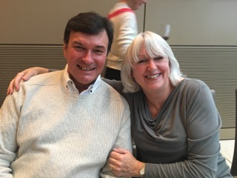
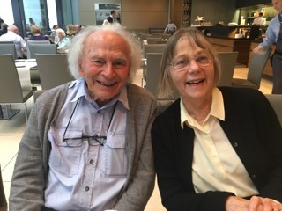
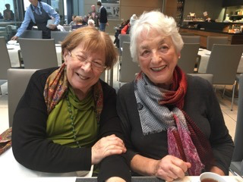
The following morning, Wednesday 28th saw us on a train to Olomouc, a lovely baroque town where a guide showed us around. With compact squares, colourful baroque houses and churches and the remains of walls sloping from its top to the bottom, it was a charming experience of old Moravia. In the evening we went to the Reduta Theatre in the same square as our hotel. This is a very contemporary transformation of an old drama theatre, ideal for small scale music theatre or spoken drama. Janacek’s first opera Sarka was given in a modern update by Opera Diversa, an ensemble specialising in contemporary music theatre. Composed before Janacek developed his unique style, the legendary setting of the opera was turned into an absurd travesty in a contemporary room with a coffin and many mobile phones, so amateurish and awful that I wanted to walk out. Luckily it lasted less than an hour.

Rod and Meg Durston John and Vanessa Mack Liz Watson and Dorothy Danta
The next evening Thursday 29th saw us return to the Brno Exhibition Centre for a large scale orchestral and choral concert featuring music by Janacek and Suk. The best known and most enjoyable piece was Janacek’s Sinfonietta , always a crowd pleaser with its panoply of brass in the first and last movements. The concert was conducted and managed by Gabriela Tardonova who conducted the Sarka of the previous evening. It was cold and unwelcoming listening to choral music in this vast space and again we were happy when it was over. Ms Tardonova clearly drew the short straw having to conduct Sarka and the choral music on successive nights. I felt quite strongly the problems of both performances were not her fault.

During our stay in Brno, Andrew Neill had introduced us to Maria Kucerova, manager of the Brno Philharmonic Orchestra. On our last day we were invited to their premises and to a final rehearsal in their lovely 19th century concert hall in the same building, designed at the same time and by the same architect who built Vienna’s great Musikverein. Though much smaller, seating only 500 people, both acoustically and visually, it is a treasure. We heard them play an unusual piece (by a composer whose name escapes me) where each short section is dominated by a single instrument like a kind of concerto for orchestra. This was followed by a fiery and exciting performence of Beethoven’s 5th Symphony. After the rehearsal I met with Maria Kucerova in her palatial office and found that despite Brno’s modest size, her orchestra permanently employed 116 musicians, had a busy year-round program of concerts, national touring, education in schools and colleges and a large and growing audience. So much so that a large 1500 seat concert hall with every modern facility was about to be built on a large site in the middle of the town.

Our final operatic performance in Brno on 309 November was arguably the finest. It was a much praised theatrical dramatisation of Janacek’s song cycle The Diary of One who Disappeared, presented by the Belgian ensemble Muziektheater Transparant, arranged by Annelies Van Parys and directed by Ivo van Hove. The series of 22 short songs tells the story of a young man who falls in love with a gipsy girl and runs away with her, all the time reflecting on the significance of what he has done. The piece was inspired by Janacek’s obsessive love for Kamila Stosslova. The treatment directed by the remarkable Dutch opera director Ivo van Hove sets it in a composer or writer’s studio with the artist and his girlfriend arguing about the implications of the songs/poems. The music and the setting was haunting and powerful.

Berlin
On Saturday 1 December we returned to Vienna airport where Andrew and Vickie Neill and our manager Claudia left us, all to return home. At the same time we were joined by my wife Sally for our group flight to Berlin. Hardly were we installed at the Melia Hotel in Friedrichstrasse, than we were out again to the opera, this time to the Staatsoper Unter den Linden, resplendent after eight years of painstaking restoration. The gorgeous foyers and the brilliant auditorium, all in white, cream and scarlet are dazzling. But this was just the precurser to a sensational evening of opera. We saw Monteverdi’s Coronation of Poppea in a marvellous production directed by Eva-Maria Höckmayr with Diego Fasolis directing the Akademie fur Alte Musik Berlin. Basically it was a simple production on a steeply sloping stage with a shimmering golden patterned curtain at the back of the stage where the characters gathered in elaborate poses when not required for the scene and watched the real action taking place downstage. The cruel and cynical drama of Nerone and his lover Poppea, his abandoned wife Ottavia and the murder of the philosopher Seneca is told with great insight and laser-like characterisation from a fantastic cast. Especially outstanding was Roberta Mameli as Poppea. To think this riveting opera was composed nearly 400 years ago! The Akademie fur Alte Musik played Monteverdi’s amazing music divinely. I found the whole thing breathtaking, just about the best production of an opera I’ve seen.

We had arrived in Berlin in the middle of the Staatsoper’s Barockdays Festival and were treated to the very best visiting ensembles and performances. Ironically it coincided with the visit to Australia of its house orchestra, the fabled Staatskapelle Berlin and its music director for life, Daniel Barenboim. In its place we had the Akademie fur Alte Musik (for Poppea), Jordi Savall’s Concert des Nations, Christophe Rousset’s Les Talens Lyrique and maybe the best of all baroque ensembles, the Freiburg Baroque Orchestra. Not bad substitutes!

On the Sunday 2 December, we attended no fewer than three performances. Rather an overload perhaps, but with such riches on offer in this premier musical city, it was impossible to resist. In the morning, we went to the new Pierrre Boulez Saal, a beautiful egg-shaped 600 seat hall designed by Frank Gehry and the new home for Barenboim’s East West Divan Orchestra and for the music school he has set up with Edward Said. The concert was by Jordi Savall and his Capella Reial and Concert de Nations presenting madrigals from Monteverdi’s 8th Book. The combination of Savall, his wonderful singers and musicians and Monteverdi’s madrigals was irresistible. In particular the performance of the long scena La Combattimento di Tancredi e Clorinda with their fabulous tenor singing the narrative with eye-riveting intensity was nothing short of overwhelming.

We had pre-arranged a lunch at a nearby restaurant as the afternoon concert by Les Talens Lyrique was a street away at the newly restored Apollo Saal in the Staatsoper, a glittering Baroque marvel. We heard French baroque cantatas by Rameau and his contemporaries Leclair and Monteclair given by a small ensemble and a soprano directed from the harpsichord by Christophe Rousset. It was virtuosic small scale pastoral stuff, rather pale and wan after the gutsiness of Monteverdi.

We caught taxis across town immediately after the performance from the Staatsoper to the Deutsche Oper, the second of Berlin’s three main opera houses for a 6 pm performance (no time for dinner) of Giordano’s classic verismo opera Andrea Chenier. The production was appropriately colourful and dramatic with both the lead tenor and baritone outstanding in their roles. Marie Jose Siri as the heroine Madeleine was also excellent. What a day we had! Everyone was exhausted and that night fell into bed.

There were no performances the next day so it was a chance for everyone to go to their favourite museum or simply relax.

On 4 December we were back at Deutsche Oper for a performance of Offenbach’s Tales of Hoffmann. This is Offenbach’s only real opera (besides about 100 operettas), and an opera I love with affectionate memories of Opera Australia’s terrific production of the 70s and 80s. This famous production by Laurent Pelly opened the new opera house in Lyon back in 2005 and has been seen and admired in many places. It features elaborate sets that constantly shift and create new perspectives, but the whole production is suffused in a pale greenish purple haze which I found depressing and antipathetic to the macabre romance of ETA Hoffmann’s story. It was well performed but I hankered after Joan Sutherland, Ray Myers , Graeme Ewer and Henri Wilden in Sydney.

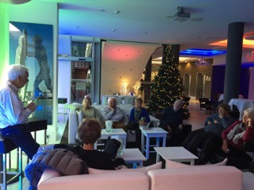
Our penultimate day of the tour took us to Berlin’s superb concert hall the Philharmonie, built in 1963 in what was then No Man’s Land between the East and West sectors of Berlin. its assymetric seating layout with the stage almost in the middle was years ahead of its time and its excellent acoustics have proved its worth. The concert was sensational; we had Teodor Currentzis’ orchestra he calls MusicAeterna which hails from Perm, an industrial city in Siberia where its day job is to play for the Perm Opera and Ballet. Currenzis is a tall charismatic Greek who appears on the stage in a kind of caftan and has been drilling his musicians day and night for years so that they now are the most ‘in demand’ musical product in the world today. As a result, for us this program of Mahler songs and the 4th Symphony was eagerly anticipated. The Knaben Wunderhorn songs were gracefully sung with soft and subtle accompaniment from the orchestra. After the interval, the virtuosity of the orchestra and the extreme variations in dynamics from the quietest pianissimo were immediately apparent. It was a supremely asssured performance of great beauty with superb orchestral playing. It was greeted with a standing ovation with Currentzis and all members of the orchestra giving full simultaneous 90 degree bows. Currentzis gave a little speech and introduced a young composer whose new piece lasting nearly 15 minutes was given an electrifying performance that ultimately had the audience rising to their feet and shouting their excitement in the aisles.
A talk in the hotel in Berlin

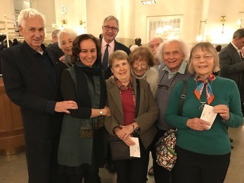
The final performance on 6 December was in prospect, the biggest of them all. Rameau’s Hippolyte et Aricie in a new production for Staatsoper Berlin’s BarockDays Festival with the famed Freiburg Baroque Orchestra under Simon Rattle and a starry cast. The direction and lighting was done by leading designer Olafur Eliasson. Rattle said in the notes he had always wanted to work with him. It turned out to be a disaster from a visual point of view. The stage was bare and flat throughout, all scenic elements being created through lighting, much of it by laser and much of that directly focused, by accident or design, into the eyes of the audience. The costumes had no sense of any period, their design often being as a vehicle for the lighting. The singing was good, the orchestra gorgeous, but the distraction and irritation caused by the visuals so great that the performance was to a considerable degree ruined. Indeed one of our group became ill through the effects of the lighting and had to leave at the interval. A classic case of too many expert cooks spoiling the broth. I hazard a guess that the fame of Rattle, Eliasson and the choreographer Aletta Collins was so great, that neither the intendant nor any of these artists were prepared to make the basic call that the stage design and lighting were awful and must be changed.

Antony Jeffrey

(Belatedly) May 2019

The group (Most of these photos were taken by Sarah Labade!)

